**SSWD CA2**

Stephen Murphy

**App function: Car Insurance - broker dashboard**

The web application I am developing is a simple directory of persons & the vehicles under which they are insured, and a log of any accidents these vehicles have been involved in. This type of app might be the type that a typical insurance brokerage might use to maintain their records for customers.

The main functionality:

* Present user with a list of Persons insured
* Present user with a list of Vehicles which lists insured driver(s) as an attribute
* Present user with a list of recorded accidents and their details (maybe could add a “filter by date” feature here?)
* Present user with a unified table which lists all Vehicles and Accidents that have been recorded involving them, listing the damage amount as an attribute

See the ERD below for the storage topology.

**Person – Vehicle has a “One to Many” relationship:** An individual can be insured to drive one or more vehicles.

**Vehicle – Accident has a “Many to Many” relationship:** Many vehicles can be involved in an accident and a vehicle can be involved in many accidents. This requires an “instance of an accident” associative table – called **Vehicle_Accident** – which is “**One to Many”** to both Vehicle & Accident tables.

**Database ERD**

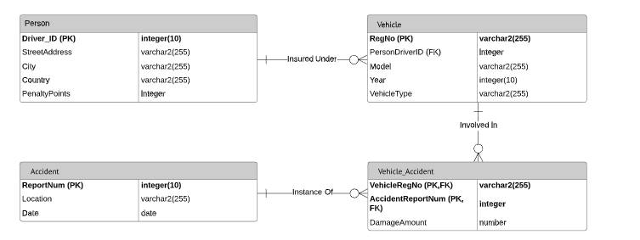

The application will be developed using a Server Side API developed using Node.js and Express in combination with a simple client side front end – with a Fetch API handling the requesting of data from the server.

The data will be stored in an Azure cloud database instance and passed to the application via the API in JSON format.

**API Definition**

**Person Table (Drivers)**

|  |  |  |  |
| --- | --- | --- | --- |
| view all | **GET** | [**http://localhost:3000/person**](http://localhost:3000/person) | All users |
| view one | **GET** | [**http://localhost:3000/person/:id**](http://localhost:3000/person/:id) | All users |
| insert | **POST** | [**http://localhost:3000/person**](http://localhost:3000/person) | Admin / Manager |
| update | **PUT** | [**http://localhost:3000/person/:id**](http://localhost:3000/person/:id) | Admin / Manager |
| delete | **DELETE** | [**http://localhost:3000/person/:id**](http://localhost:3000/person/:id) | Admin |

**Vehicle Table**

|  |  |  |  |
| --- | --- | --- | --- |
| view all | **GET** | **http://localhost:3000/vehicle** | All users |
| view one | **GET** | [**http://localhost:3000/vehicle/:id**](http://localhost:3000/vehicle/:id) | All users |
| insert | **POST** | [**http://localhost:3000/vehicle**](http://localhost:3000/vehicle) | Admin / Manager |
| update | **PUT** | [**http://localhost:3000/vehicle/:id**](http://localhost:3000/vehicle/:id) | Admin / Manager |
| delete | **DELETE** | [**http://localhost:3000/vehicle/:id**](http://localhost:3000/vehicle/:id) | Admin |

**Accidents Table**

|  |  |  |  |
| --- | --- | --- | --- |
| view all | **GET** | [**http://localhost:3000/accident**](http://localhost:3000/accident) | All users |
| view one | **GET** | [**http://localhost:3000/accident/:id**](http://localhost:3000/accident/:id) | All users |
| insert | **POST** | [**http://localhost:3000/accident**](http://localhost:3000/accident) | Admin / Manager |
| update | **PUT** | [**http://localhost:3000/accident/:id**](http://localhost:3000/accident/:id) | Admin / Manager |
| delete | **DELETE** | [**http://localhost:3000/accident/:id**](http://localhost:3000/accident/:id) | Admin |

**Vehicle/Accidents Table**

|  |  |  |  |
| --- | --- | --- | --- |
| view all | **GET** | [**http://localhost:3000/ vehicle-accident**](http://localhost:3000/%20vehicle-accident%20) | All users |
| view one | **GET** | [**http://localhost:3000/ vehicle-accident/:id**](http://localhost:3000/%20vehicle-accident/:id) | All users |
| insert | **POST** | **http://localhost:3000/ vehicle-accident/:id** | Admin / Manager |
| update | **PUT** | [**http://localhost:3000/ vehicle-accident/:id**](http://localhost:3000/%20vehicle-accident/:id) | Admin / Manager |
| delete | **DELETE** | [**http://localhost:3000/ vehicle-accident/:id**](http://localhost:3000/%20vehicle-accident/:id) | Admin |

**Submission Statement**

**General:**

* The app has a main “index.html” page containing three of the tables from my ERD. I also decided to include each table on its own individual page – to mimic a realistic app.

Although this is beyond the scope of requirements – I had experimented with trying to make index.html a unique “dashboard” view – which would pull only the 5 most recent entries for each table into it. On analysing this – I parked the idea, since I understand it would then require a separate instance of the fetch API for the dashboard – and the regular one for the existing tables. I got stuck on this, so parked the idea.

**DB:**

* Database is created and linked according to ERD spec with relationships implemented (Note the instances of DriverID, PersonDriverID, ReportNum & VehicleReportNum (all table PK/FK’s)
* All data I wanted to pull through from the DB is pulling through – I decided not to implement the “Claim Incidents” table as I felt it was a little pointless without having search or filter user features which I didn’t know how to add. However you can verify that the MTM table exists in the db (VehicleAccident) and could be used in this way with further implementation.
* DB script is provided. “CarInsuranceSetupDB.sql”

**Server API**

* Routes are defined and added as above

CRUD operations (POST, PUT, DELETE) are returning a 500 server error – which I had progressed on from working through getting 401 “Unauthorized” errors. I have experimented with turning Passport on and off – See my comments above each HTTP method in the respective files. GET / and GET /:id are working fine.

* Passport is implemented – but possibly not fully correctly ? Maybe causing or affecting the above issue…
* Data is pulling through to api client
* Have added some custom validations – but nothing fancy – just isNumeric(), assertString().. and one in there also to check for an email address format.

**Client**

* Login/logout is implemented – although while logged in the only “modal” form that will work when clicked is the Update on the Accidents.html page
* Access controls not working correctly

Stephen Murphy X00149904